**Avalon Online**

SOFTWARE REQUIREMENTS SPECIFICATION

Ryan Austin Fernandez

**Table of Contents**

|  |  |
| --- | --- |
| 1. Executive Summary | 1-1 |
| 1. Overview | 2-1 |
| * 1. Community Flow and Features | 2-1 |
| * + 1. Game Flow and Features | 2-1 |
| * + 1. Statistics | 2-2 |
| * 1. *Data Requirements for Storage of Community Records* | 2-2 |
| * 1. Roles in the Process | 2-3 |
| 1. Problem Analysis | 3-1 |
| 1. Software Solution | 4-1 |
| * 1. Objectives | 4-1 |
| * 1. Characteristics | 4-1 |
| * 1. Scope and Assumptions | 4-1 |
| 1. User Stories | 5-1 |
| * 1. <User Story 1> | 5-1 |
| Appendix A - Improved Business Process | A-1 |
| Appendix B - Sample Forms and Reports | B-1 |
| Appendix C - References and Acknowledgements | C-1 |

1. **Executive Summary**

Avalon is a board game created by Don Eskridge as an improvement over his previous board game, The Resistance, with gameplay similar to it, but with additional features.

The game involves the Knights of the Round Table attempting to succeed in three quests ordered by King Arthur. However, there are treacherous minions of Mordred amongst the loyal servants of Arthur attempting to fail the missions. It is the loyal servants’ mission to discover the identity of the traitors

The additional features of Avalon with respect to The Resistance are its additional character cards: Merlin, Assassin, Perceval, Morgana, Mordred, Oberon, and the Lady of the Lake adding more social dynamics to the gameplay. (The Resistance, n.d.)

1. **Overview of the Business Process**

*This chapter presents an overview of a simple Avalon gaming community’s regular operations flow. Included in this chapter are the following items:*

* *Community Flow and Features*
* *The game’s flow and features*
* *Data requirements for storage of game records*
* *Different kinds of users in the community*
* *Proposed site’s user privileges*

**2.1 Community Flow and Features**

In the community, at most one game may be hosted by a member. That game can be joined or left by the host’s friends in the community, or anyone for community games. Once the maximum number of players (set by the host) or less, depending on whether the host wants to begin or not, have been met, the game begins. A game may also be cancelled before it begins.

A member may flag another member for misdemeanor, to be reviewed by a moderator or an administrator. An administrator may grant a member the rank of moderator or administrator.

2.1.1. Game Flow and Features

Each game has five to ten players and has a role distribution phase, a quest phase, and an end phase.

Given n players, there are minions of Mordred present. At the beginning of the game, the roles, whether a player is a servant of Arthur (good) or a minion of Mordred (evil), are randomly distributed. The minions of Mordred then secretly discover each other’s identities (in physical games, this is done by everyone closing their eyes then the minions open their eyes).

The quest phase comprises of five quests, each with sub phases, namely the selection, discussion, approval, quest proper, and reveal phases. A team captain is randomly designated at the beginning of the game. This team captain selects the appropriate number of people for the quest depending on how many players and which quest it is in the game. (see Appendix B-1). Once a team is selected, the players then discuss the composition of the team. Once a discussion has been raised, they will now vote on whether they approve or reject the team. If the majority (for even number of players, ties are not majority) approves, the selected players go on a quest and may choose to play a success or fail card. If the vote fails, the team captain token is passed to the left and the selection, discussion, and approval sub phases repeat. If the approval phase fails five times for a particular quest, evil automatically wins. Loyal servants of Arthur have to play a success card. Minions of Mordred may choose to play success or fail. Once they secretly give the team captain their decisions, the team captain shuffles the cards and reveals them one by one. If at least one fail is present, the mission fails and the appropriate mission marker is placed on the game board (see Appendix B-2). An exception is made for the fourth quest in games of more than seven players. It will take two fails for such quests. After each quest, team captain passes to the left.

Before the explanation of the end phase, it is necessary to discuss two optional special characters: Merlin and Assassin. When these two are in play, at the beginning, the evil players raise their thumbs and Merlin opens his eyes. Therefore, evil is revealed to Merlin. He may then influence the flow of the game. In the end phase, if one team has succeeded or failed in three quests, that team wins. However, if the good team has won, the assassin may now guess who among the good players Merlin is. If he is successful, the evil team still wins. A game with Merlin cannot be played without Assassin.

As for the other special characters, Perceval knows who Merlin is; Morgana appears as Merlin to Perceval; Mordred is hidden from Merlin; and Oberon is hidden from the evil players, but the evil players are also hidden from him. Oberon may choose to fail a mission if he pleases.

Regarding the Lady of the Lake, at the beginning of the game, the Lady token is given to the person to the right of the Team Captain. After the second quest, this person must choose a player to use the Lady of the Lake on. This player is given a red (evil) and a blue (good) loyalty card. They must give their loyalty card to the person who used the Lady of the Lake, who then returns the loyalty card. The Lady of the Lake is passed to the player it was used on and the previous user is now immune to the Lady of the Lake. The former user may now discuss the card that was given to him, even if he lies. This is repeated for the third and fourth quests.

Targeting is also an advanced game option. The team captain may choose to do the quests in any order, except the fifth quest, which may only be attempted after two successes. The fourth quest for games with at least seven players still require two fails. The Lady of the Lake still only functions after the second, third, and fourth quests.

After the game is finished, the statistics of the game are tallied. The members of the community may view these statistics for future reference, either on a per game basis or in total for each member or the entire community.

*The business process can be visualized in the diagram shown in Figure 2-1.*

*<insert your business process diagram here>*

*Figure 2-1. Existing Business Process*

2.1.2. Statistics

The community and member statistics may be viewed by any member at any time. The specific details of which are further discussed in section 2.2.

***2.2 Data Requirements for Storage of Community Records***

Each member has a first name, a last name, a username, a password, a bio, a member level (bronze after playing 50 games, silver after playing 125 games, gold after playing 250 games), and an authorization level (regular, moderator, administrator). A member may only join one game at any given time.

Each game has a game id number, date and time hosted and ended, whether it is ongoing, whether it is a community or “friends-only” game, an optional minimum number of players (which cannot go below five), an optional maximum number of players (which cannot exceed ten), a list of special characters included, whether targeting is enabled, whether the Lady of the Lake is enabled, number of successes, number of fails, winner, and any discussion comments (similar to a chatbox) made during the game.

Each quest has at least one and at most five selections, with the captain who chose the team, each player’s vote for each selection and whether it was approved. It also has the quest results, with each member of the quest’s played card (success or fail) and the result of the quest.

For games with the Lady of the Lake, it is also necessary to mark players who are immune to the Lady of the Lake at any given point in time.

The community statistics comprises total games good won, evil won, good v. evil ratio, total game forfeits, total evil default wins (through five team rejections in one quest), and total games played.

The player statistics are total games played as good; total games played as evil; total games won and lost, as evil, as good, and in total; total games as any of the special roles; total games hosted; and total games played.

***2.3 Roles in the Process***

There are various kinds of members in the Avalon Game Community as shown in Table 2-1.

|  |  |
| --- | --- |
| Role | Description of Tasks |
| Member | * Hosts a game * Cancels a game * Joins a game * Begins a game   + Selects special characters for a game   + Sets special rules for a game   + Selects members to go on a quest   + Votes for a team   + Determines success of a quest   + Discuss the game * Flags a user * View Community Statistics * View User Profile (with statistics) * Edit Own Profile |
| Moderator | * All member privileges * Moderates flagged users |
| Administrator | * All moderator privileges * Grants moderator or administrator privileges |

Table 2-1. Member hierarchy in the Avalon Online

1. **Problem Analysis**

This chapter presents the findings of the investigation on the organization’s needs and problems to be addressed by the software. (Only problems to be ADDRESSED) This section will also provide the reader with a background of the organization which is the primary stakeholder of the system to be developed. The various users and stakeholders of the software are also presented here.

| **ID** | **Description** | **Cause** | **Symptoms** | **Impact** |
| --- | --- | --- | --- | --- |
| # | What’s the problem? | What causes the problem? | How do we know the problem exists? | Why is this important? What are the consequences? |
|  |  |  |  |  |
|  |  |  |  |  |
|  |  |  |  |  |
|  |  |  |  |  |
|  |  |  |  |  |
|  |  |  |  |  |

***The section ends with the statement of the problem, need or opportunity where the software is the proposed solution (BUSINESS REQUIREMENT).***

1. **Software Solution** 
   1. **Objectives**

The Avalon Online Web Application aims to provide an online community for regular Avalon players to interact and play the game.

*“The specific objectives of the software are as follows:*

* *To provide a facility for managing the records of call center applicants, from resume to training plans;*
* *To provide a facility for tracking the employment history of call center applicants;*
* *To provide a facility for managing the scheduling of training courses;*
* *To provide a facility for call center companies to register with ECTPA;*
* *To provide a facility for managing job openings transactions from request to deployment;*
* *To generate various reports for monitoring call center operators, companies and job openings”* 
  1. **Characteristics**

This section discusses the non-functional requirements that need to be addressed to achieve the business goals stated in Chapter 2.

**4.3. Assumptions, Scope, and Limitations**

1. **User Stories**

*This chapter presents the user stories included in the product backlog.*

|  |  |
| --- | --- |
| **User Story #1:** A non-registered user can register his/her account to be able to access the other features of the system. | |
| **Estimate (Days):** 8 hours | **Priority:** 10 |
| **Pre-condition:** The user is on the register screen. | |
| **Scenario:**   1. The user inputs their first name, last name, username, password (twice), and bio. 2. The system verifies that the username is unique and notifies the user if otherwise. 3. The system verifies that the passwords match and notifies the user otherwise. 4. The system registers the new user data in the database. The password is salted and hashed. 5. The system displays the login screen. | |
| **Post-condition:**  The user can now log in to the site. | |
| **Acceptance Criteria:**   1. Test if the system correctly determines if the username is unique and displays an error message if otherwise. 2. Test if the system correctly determines if the passwords match and displays an error message if otherwise. 3. Test if the system salts and hashes the password. 4. Test if the data was added to the database correctly. | |

**5.1. Register Account**

**5.2. Login User**

|  |  |
| --- | --- |
| **User Story #2:** A user that is not logged in may log in to access the user privileges. | |
| **Estimate (Days):** 8 hours | **Priority:** 10 |
| **Pre-condition:** The user is registered and is viewing the login screen. | |
| **Scenario:**   1. The user inputs their username and password. 2. The system checks if the username exists and displays a message if otherwise. 3. The system checks if the username matched with the password and displays a message if otherwise. 4. The system logs the user in. 5. The system displays the home screen. | |
| **Post-condition:**  The user may now access the site’s features. | |
| **Acceptance Criteria:**   1. Test if the system checks the username’s existence correctly and displays an error message. 2. Test if the system checks the password correctly and displays an error message if not a match. 3. Test if the system logs the user in and the user can access the site features. | |

**5.3. Host Game**

|  |  |
| --- | --- |
| **User Story #3:**A user can host a game to gather players for gameplay. | |
| **Estimate (Days):** 8 hours | **Priority:** 10 |
| **Pre-condition:** The user is logged in. | |
| **Scenario:**   1. The user selects to host a game. 2. The user selects if it is a community or friends-only game. 3. The user inputs the minimum and maximum number of players (0 if not applicable). 4. The system registers the game in the database. 5. The system displays the game details screen. | |
| **Post-condition:**  The game is now visible to the appropriate members of the community. | |
| **Acceptance Criteria:**   1. Test if the user inputs a negative number for maximum or minimum number of players and displays an error message when such event occurs. 2. Test if the game is registered into the database correctly. | |

**5.4. Cancel Game**

|  |  |
| --- | --- |
| **User Story #4:** A user can cancel a game to withdraw a game from the official listings | |
| **Estimate (Days):** 4 hours | **Priority:** 20 |
| **Pre-condition:** The user has hosted a game, is viewing the game details screen, and has not begun the game. | |
| **Scenario:**   1. The user chooses to cancel the game. 2. The system asks for confirmation. 3. The user selects to confirm or cancel. 4. If the user confirmed, the game is cancelled in the database. 5. The system displays the home screen. | |
| **Post-condition:**  The game is now cancelled. | |
| **Acceptance Criteria:**   1. Test if the system asks for confirmation. 2. Test if the system cancels the game in the database. | |

**5.5. Join Game**

|  |  |
| --- | --- |
| **User Story #5:** A user can join a game in order to participate in gameplay. | |
| **Estimate (Days):** 4 hours. | **Priority:** 10 |
| **Pre-condition:** The user is on the home screen. | |
| **Scenario:**   1. The user chooses to view hosted games. 2. The system displays all games. 3. The user may choose to filter friends-only games.    1. The system displays games that are classified as friends-only. 4. The user selects a game. 5. The system displays that game’s details. 6. The user chooses to join the game. 7. The system checks if the user had already joined a game beforehand and displays an error if so. 8. The system checks to see if the maximum number of players has been exceeded and displays an error if so. 9. The system marks that user as joined. | |
| **Post-condition:**  The user can now play the game once it begins. | |
| **Acceptance Criteria:**   1. Test if the system displays only non-cancelled, non-ongoing games. 2. Test if the system filters friends-only games properly. 3. Test if the system checks if the user had already joined a game beforehand and displays an error if so. 4. Test if the system checks the maximum number of players correctly and displays a proper error message. 5. Test if the user is added to the game’s roster in the database. | |

**5.6. Begin Game**

|  |  |
| --- | --- |
| **User Story #6:** A user can begin a game to start gameplay. | |
| **Estimate (Days):** 16 hours | **Priority:** 10 |
| **Pre-condition:** The user must be the one hosting the game and is viewing the game details screen. | |
| **Scenario:**   1. The user chooses to begin the game. 2. The system checks if the minimum number of players have been met. 3. The system marks the game as begun. 4. The system distributes the characters to the players. 5. The system displays the minions of Mordred to each | |
| **Post-condition:** | |
| **Acceptance Criteria:** | |

**5.7. Select Special Characters**

|  |  |
| --- | --- |
| **User Story #7:** | |
| **Estimate (Days):** | **Priority:** |
| **Pre-condition:** | |
| **Scenario:** | |
| **Post-condition:** | |
| **Acceptance Criteria:** | |

**5.8. Select Special Rules**

|  |  |
| --- | --- |
| **User Story #8:** | |
| **Estimate (Days):** | **Priority:** |
| **Pre-condition:** | |
| **Scenario:** | |
| **Post-condition:** | |
| **Acceptance Criteria:** | |

|  |  |
| --- | --- |
| **User Story #9:** | |
| **Estimate (Days):** | **Priority:** |
| **Pre-condition:** | |
| **Scenario:** | |
| **Post-condition:** | |
| **Acceptance Criteria:** | |

**5.9. Select Quest Members**

|  |  |
| --- | --- |
| **User Story #10:** | |
| **Estimate (Days):** | **Priority:** |
| **Pre-condition:** | |
| **Scenario:** | |
| **Post-condition:** | |
| **Acceptance Criteria:** | |

**5.10. Vote For Team**

**5.11. Determine Success of Quest**

|  |  |
| --- | --- |
| **User Story #11:** | |
| **Estimate (Days):** | **Priority:** |
| **Pre-condition:** | |
| **Scenario:** | |
| **Post-condition:** | |
| **Acceptance Criteria:** | |

**5.12. Discuss Game**

|  |  |
| --- | --- |
| **User Story #12:** | |
| **Estimate (Days):** | **Priority:** |
| **Pre-condition:** | |
| **Scenario:** | |
| **Post-condition:** | |
| **Acceptance Criteria:** | |

**5.13. Flag User**

|  |  |
| --- | --- |
| **User Story #13:** | |
| **Estimate (Days):** | **Priority:** |
| **Pre-condition:** | |
| **Scenario:** | |
| **Post-condition:** | |
| **Acceptance Criteria:** | |

**5.14. Moderate User**

|  |  |
| --- | --- |
| **User Story #14:** | |
| **Estimate (Days):** | **Priority:** |
| **Pre-condition:** | |
| **Scenario:** | |
| **Post-condition:** | |
| **Acceptance Criteria:** | |

**5.15. Friend User**

|  |  |
| --- | --- |
| **User Story #15:** | |
| **Estimate (Days):** | **Priority:** |
| **Pre-condition:** | |
| **Scenario:** | |
| **Post-condition:** | |
| **Acceptance Criteria:** | |

**5.16. View Friends**

|  |  |
| --- | --- |
| **User Story #16:** | |
| **Estimate (Days):** | **Priority:** |
| **Pre-condition:** | |
| **Scenario:** | |
| **Post-condition:** | |
| **Acceptance Criteria:** | |

**5.17. Alter User Level**

**5.18. View User Profile**

|  |  |
| --- | --- |
| **User Story #17:** | |
| **Estimate (Days):** | **Priority:** |
| **Pre-condition:** | |
| **Scenario:** | |
| **Post-condition:** | |
| **Acceptance Criteria:** | |

|  |  |
| --- | --- |
| **User Story #18:** | |
| **Estimate (Days):** | **Priority:** |
| **Pre-condition:** | |
| **Scenario:** | |
| **Post-condition:** | |
| **Acceptance Criteria:** | |

**5.19. Edit Profile**

|  |  |
| --- | --- |
| **User Story #19:** | |
| **Estimate (Days):** | **Priority:** |
| **Pre-condition:** | |
| **Scenario:** | |
| **Post-condition:** | |
| **Acceptance Criteria:** | |

|  |  |
| --- | --- |
| **User Story #20:** | |
| **Estimate (Days):** | **Priority:** |
| **Pre-condition:** | |
| **Scenario:** | |
| **Post-condition:** | |
| **Acceptance Criteria:** | |

**5.20. View Community Statistics**

**Appendix A – Improved Business Process**

*This chapter presents the improved business process when the proposed software solution is implemented. This visualizes how the software solution benefits or affects the current business process.*

**Appendix B – Sample Forms and Reports**

*This chapter contains the various gameplay materials needed for the site.*

B-1. Player/Quest Table

This table notes the number of players to send on each quest in the game, depending on the total players.

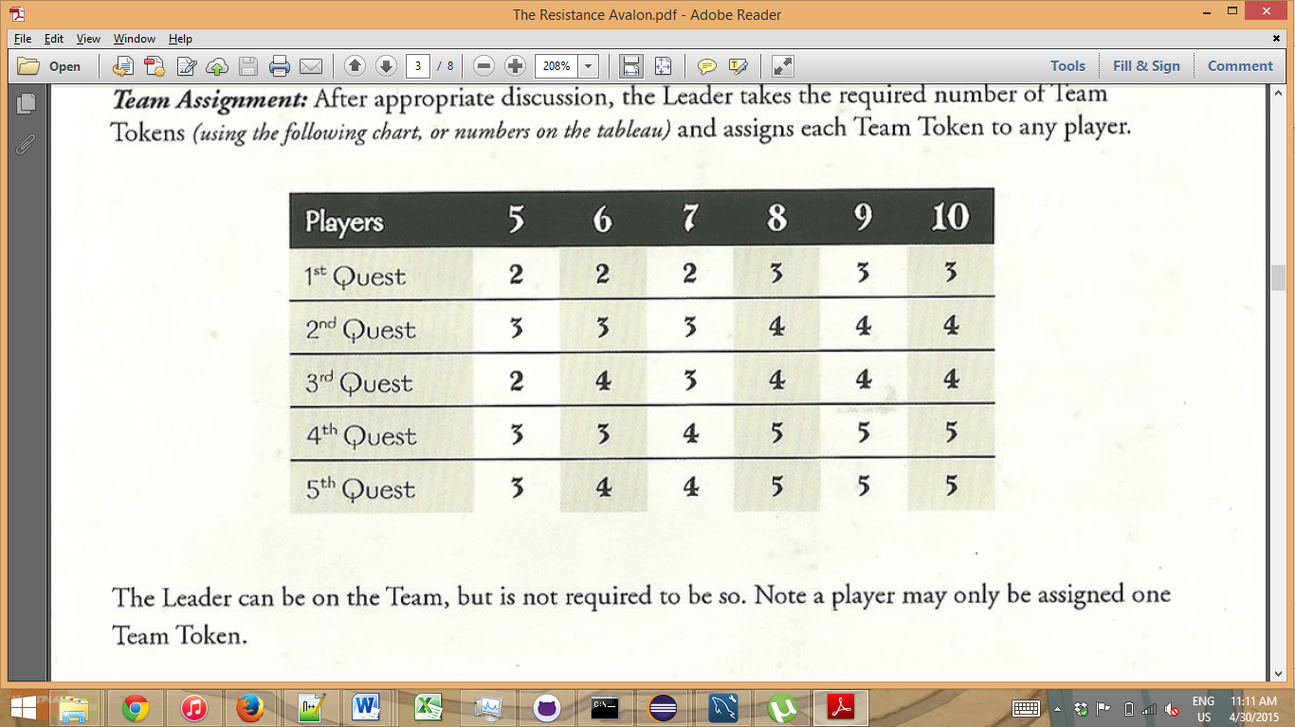

B-2. Score Tableau

This is a sample of a score tableau used for the game.

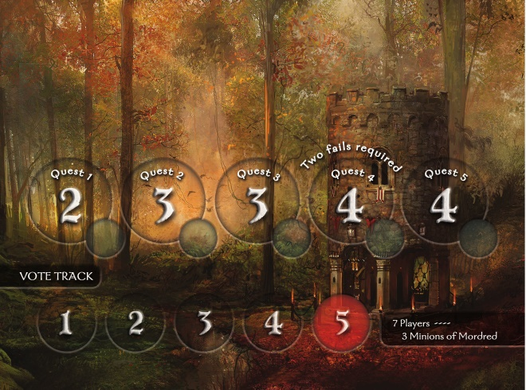

**Appendix C – References and Acknowledgement**

The Resistance. (n.d.). Retrieved April 30, 2015, In Wikipedia: http://en.wikipedia.org/wiki/The_Resistance

_%28game%29